Predicting Earthquake Magnitude from AZGS Catalog Features
Paul T. Allen
ISTA 421
Spring 2026

Section 1 – Problem Formulation and Significance
  - Problem Statement
This project asks whether earthquake magnitude can be predicted from the same detection parameters that a seismic analyst sees when an event is located. These include depth, number of phases picked, location residuals, horizontal and vertical uncertainty, and epicenter coordinates. The main research question is: can earthquake magnitude be predicted from catalog and location-quality features alone, without using waveform amplitude?
A secondary question is whether a non-linear model performs better than a regularized linear model, or whether ordinary least squares performs just as well. The task is supervised regression because the target, earthquake magnitude, is continuous. Three models are compared: ordinary least squares regression, Ridge regression, and a Decision Tree regressor. All three are implemented from scratch in NumPy and evaluated using R², RMSE, and MAE.
Three hypotheses guide the analysis. First, Number of Phases will be the strongest predictor because larger events are usually recorded by more stations and have more picked arrivals. Second, Ridge regression will perform very similarly to OLS because the main multicollinearity issue, the Rms-Erh pair, is moderate. Third, the Decision Tree may capture some weak non-linear structure, but it will not dramatically outperform the linear models.
  - Significance
This project matters because the Arizona Geological Survey maintains a statewide earthquake catalog used by emergency managers, hazard modelers, and researchers. A model like this would not replace the actual magnitude calculation. The more realistic use is as a simple quality-control check. If an event’s recorded magnitude looks very different from what the detection parameters suggest, then it could be flagged for a second look.
Scientifically, the model results can also show which detection parameters carry the most information about magnitude. For example, if Number of Phases dominates the model, that says something useful about how event size, station detection, and phase picking are connected in the Arizona catalog. The same general workflow could also be applied to other regional seismic networks with similar catalog data.
A major limitation is that true magnitude is calculated from waveform amplitude, and waveform amplitude is not included here. So I would not expect the model to perfectly predict magnitude. If the R² has a ceiling, that is partly because the most important information is missing, not just because the algorithms failed.
  - Dataset Description
The dataset is the Arizona Geological Survey statewide earthquake catalog from May 2019 through November 2025. The raw catalog contains 4,756 events. After filtering for complete entries and removing obvious data-entry errors, the final cleaned dataset contains 782 events. The full cleaning process is described in Section 2.1.
The target variable is Magnitude, which ranges from 0.4 to 4.5 in the cleaned dataset. Magnitude is logarithmic, so an M3 earthquake releases about 32 times more energy than an M2 earthquake. This helps explain why the catalog is right-skewed, with many small events and fewer large ones.
The predictors are Depth, Number of Phases, Rms, Erh, Erz, longitude, latitude, and Type. Depth measures how far below the surface the event occurred. Number of Phases is the count of picked P and S arrivals. Rms measures the time-residual misfit of the location solution, while Erh and Erz measure horizontal and vertical uncertainty. Longitude and latitude describe event location. Type records whether the magnitude is ML or MD and is encoded as the binary variable Type_ML.
This dataset is suitable because it is real operational catalog data, has a clear prediction target, includes both continuous and categorical predictors, and has 782 cleaned observations, which is well above the assignment minimum.

Section 2 - Exploratory Data Analysis
2.1 Handling Missing / Imbalanced Data
Before making figures or fitting models, I cleaned the dataset so all later analysis used the same final set of events. The raw AZGS catalog started with 4,756 events. I first dropped administrative columns that were not useful for prediction: GlobalID, TImeTest, Mercalli, CreationDate, EditDate, Location, and Notes. I then converted the quantitative columns to numeric values, with blank or non-numeric entries converted to NaN.
Rows with NaN or zero values in any quantitative field were removed, leaving 789 events. Zero values in fields like Depth, Erh, or Erz were treated as data-entry problems rather than real measurements. I then removed one clear outlier with an Rms of 101 seconds, leaving 788 events. Next, I removed events outside the approximate Arizona bounds, leaving 785 events. Finally, I removed the three Mw-scale events, since there were too few to model and Mw is different from ML and MD. The final cleaned dataset contains 782 events. The Type column was then encoded as Type_ML, where 1 means ML and 0 means MD.
The cleaned data are imbalanced in two ways. Magnitude is right-skewed, with a mean of 1.74, median of 1.6, and maximum of 4.5. Most events are below magnitude 2.0, which is expected for earthquake catalogs. Type is also imbalanced, with 732 ML events and 50 MD events.

2.2 Summary Statstics and Single-Variable Distributions
The summary statistics show that the cleaned catalog is dominated by small earthquakes. Magnitude has a mean of 1.74, median of 1.6, standard deviation of 0.59, and range of 0.4 to 4.5. Number of Phases is also right-skewed, with a mean of 12.79, median of 10, and maximum of 74. This means most events have a modest number of picked arrivals, while a few better-recorded events have many more.
Figure 1 shows the magnitude histogram. The distribution has a modal value near M 1.5 and a long upper tail to M 4.5. Figure 2 compares magnitude by Type. The catalog contains 732 ML events and 50 MD events. ML events span the full range from 0.4 to 4.5, while MD events are concentrated between M 1.0 and M 2.3. Because there are so few MD events, the Type variable should be interpreted carefully in the model results.
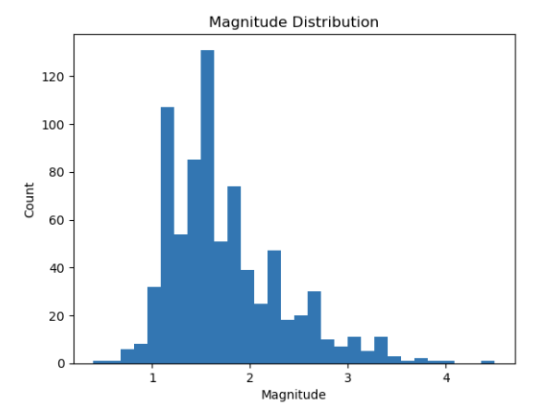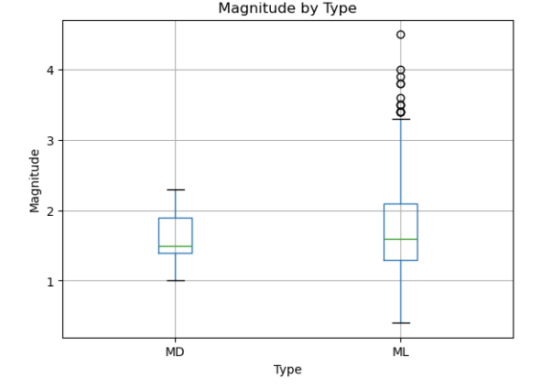
Figure 1: Distribution of magnitudes in the cleaned catalog, n = 782. The distribution is right-skewed, with a modal value near M 1.5 and a long upper tail extending to M 4.5.
Figure 2: Magnitude by detection type. ML events, n = 732, span the full range. MD events, n = 50, are concentrated between M 1.0 and M 2.3, with mean 1.60.

2.3 Relationships, patterns, and visualizations
The scatter plots show that Number of Phases has the clearest relationship with Magnitude. Events with more picked phases tend to have larger magnitudes, which makes sense because larger earthquakes are usually recorded by more stations. Depth has a weaker negative relationship with Magnitude, while Rms does not show a strong visual trend.
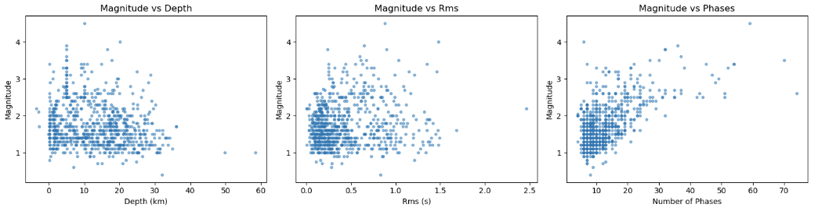
Figure 3: Magnitude versus three key predictors. The Phases panel shows the clearest positive trend; Depth shows a weak negative trend; Rms is essentially flat.
The correlation matrix supports the same pattern. Number of Phases has the strongest correlation with Magnitude, with r = 0.61. Latitude has a weak negative correlation with Magnitude, r = -0.22, and Depth also has a weak negative correlation, r = -0.19. The main predictor relationship to watch is between Rms and Erh, r = 0.71. This is the strongest correlation between two predictors and is the main reason Ridge regression is included later.
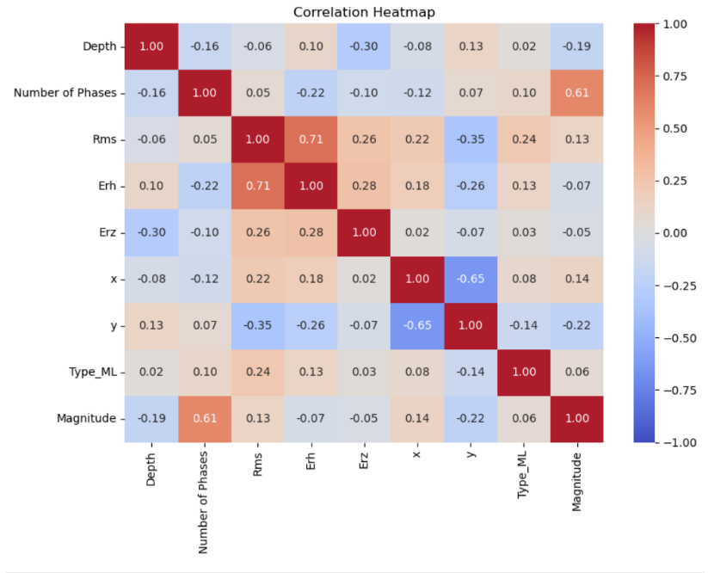
Figure 4: Correlation matrix for all predictors and the target
The geographic scatter plot shows that earthquakes are not evenly distributed across Arizona. Most events are clustered in northern Arizona, especially around the Colorado Plateau and Mogollon Rim, with another cluster in the southeast. This matters because spatial predictors may partly reflect station coverage and catalog density, not only earthquake physics.
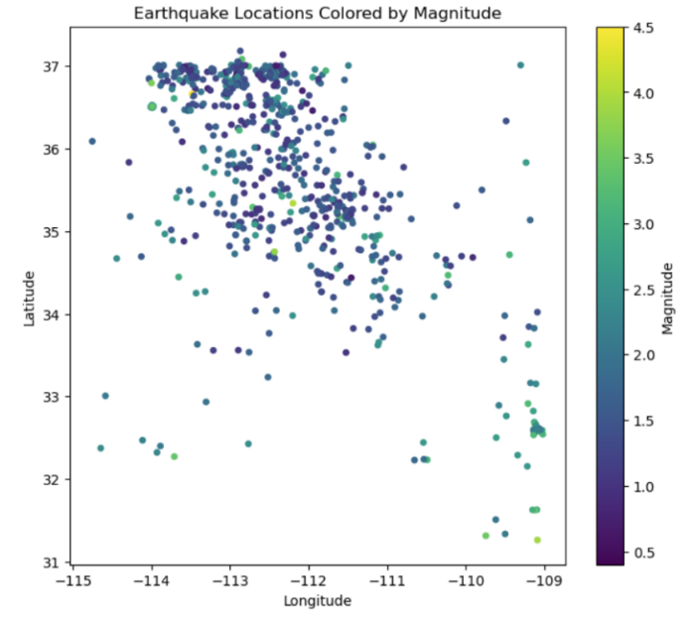
Figure 5: Spatial distribution of events, colored by magnitude. Most seismicity clusters in northern Arizona, including the Colorado Plateau and Mogollon Rim, with a secondary cluster in the southeast.

Section 2 – Model Selection, Application, and Evaluation
3.1 Justify Model Choice
I chose three models that move from simple to more flexible: OLS, Ridge regression, and a Decision Tree regressor. This gives a clear comparison between an unregularized linear model, a regularized linear model, and a non-linear model.
OLS is the baseline because it tests whether magnitude can be predicted from a simple linear combination of the catalog features. Ridge is included because Rms and Erh are moderately correlated, with r = 0.71. The L2 penalty can shrink correlated coefficients without removing either variable. The Decision Tree is included to test whether non-linear patterns or feature interactions improve prediction. It is also useful because its splits are easy to interpret and could translate into simple catalog QC rules.
Together, these models test a simple question: does making the model more flexible actually help, or is most of the useful signal already captured by a linear model?

3.2 Method Applications
All three models used the same 80/20 train/test split with random_state = 36, giving 625 training events and 157 test events. For OLS and Ridge, I standardized the seven continuous predictors using only the training-set mean and standard deviation. I did not standardize Type_ML because it is already a 0/1 indicator. The Decision Tree did not require standardization because tree splits are based on thresholds.
All three models were implemented with NumPy. I did not use sklearn for model fitting, although train_test_split was used to create the training and testing sets.
OLS regression was implemented with batch gradient descent using mean squared error, a learning rate of 0.05, and 5,000 epochs. Ridge regression used the same structure, but added an L2 penalty to the weight update. The bias term was not penalized. I tested 30 λ values from 0.001 to 1000 using 5-fold cross-validation. The best value was λ = 0.0728, with a CV RMSE of 0.4491. Since the best λ was very small, Ridge was basically acting a lot like OLS in the final model.
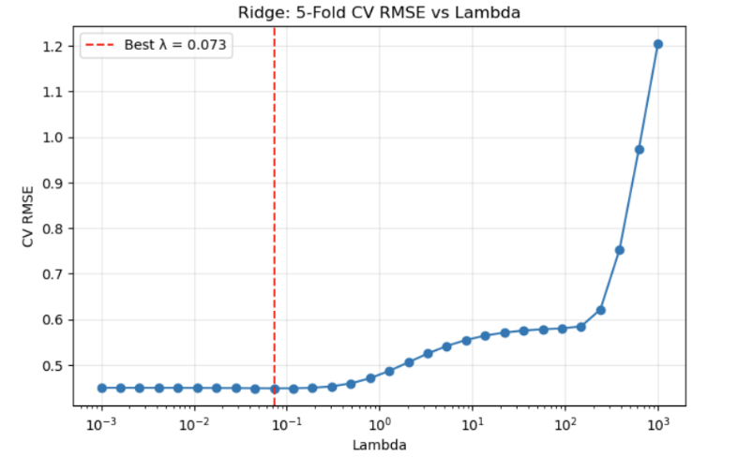
Figure 6: 5-fold cross-validation RMSE versus regularization strength λ.
The Decision Tree was also implemented from scratch. At each split, the code searched possible features and threshold values and chose the split that minimized the total child-node sum of squared error. The tree used min_samples_split = 10, and max_depth was tuned with 5-fold cross-validation. I tested depths from 2 through 8. The best tree had a max depth of 3, with a CV RMSE of 0.4431. Deeper trees performed slightly worse, suggesting overfitting.
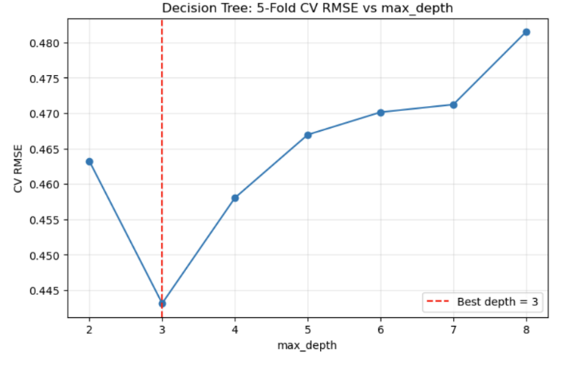
Figure 7: 5-fold cross-validation RMSE versus max_depth for the Decision Tree.

3.3 Model Evaluation
The three models were evaluated on the same held-out test set of 157 events. I used three regression metrics: R², RMSE, and MAE. R² measures how much variance in magnitude the model explains, while RMSE and MAE measure the size of the prediction errors in magnitude units.
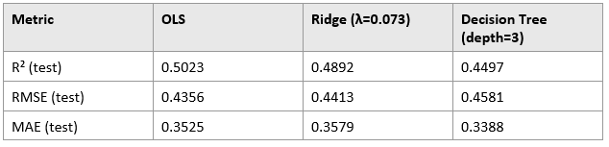
Table 1
Overall, all three models perform fairly similarly. The R² values range from about 0.45 to 0.50, meaning the models explain roughly half of the variation in magnitude. The RMSE values are also close, ranging from 0.4356 to 0.4581, and the MAE values range from 0.3388 to 0.3579. The main result is that increasing model flexibility does not dramatically improve performance on this dataset.
OLS performs best on R² and RMSE, with an R² of 0.5023 and RMSE of 0.4356. Ridge is very close to OLS, which matches the cross-validation result that only a very small amount of regularization was needed. The Decision Tree performs worse on R² and RMSE, but it has the best MAE at 0.3388. This makes sense because the tree predicts using a small number of leaf averages. It can do well for the dense middle of the magnitude distribution, but it struggles more with the sparse upper tail, where magnitudes above 3 are rare.
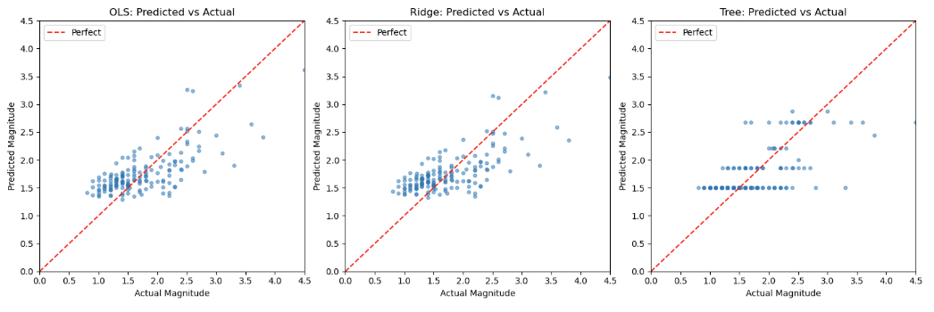
Figure 8: Predicted versus actual magnitude on the test set for each model.
The coefficient plot also shows that Ridge and OLS learned almost the same model. In the Ridge model, Number of Phases is the dominant predictor, with a standardized coefficient of +0.314. The next-largest coefficient is latitude, y, at -0.110. All other coefficients are much smaller: longitude is +0.050, Rms is +0.033, Depth is -0.031, Type_ML is -0.021, Erh is -0.020, and Erz is -0.017. This means Number of Phases is roughly three times larger than the next strongest predictor on the standardized scale.
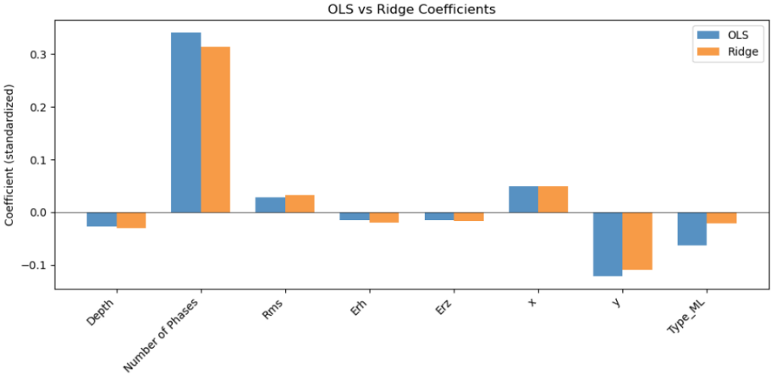
Figure 9: Standardized coefficients for OLS and Ridge.
The Decision Tree gives a useful comparison to the linear models. Of the eight predictors, the tree only uses three: Number of Phases appears in 4 splits, latitude appears in 2 splits, and Rms appears in 1 split. Depth, Erh, Erz, longitude, and Type_ML are never used. This is important because the tree was free to choose any feature at each split, but it still focused on the same main variables suggested by the linear models.
Overall, the model evaluation supports the main hypotheses. Number of Phases is clearly the most important predictor, Ridge performs almost the same as OLS, and the Decision Tree does not provide a major improvement. The signal in the catalog features is real, but limited. More model complexity does not solve the main limitation, which is that waveform amplitude is not included as a predictor.

Section 4 – Results, Conclusion, and Real-world Implications
4.1 Results Presentation
The results in Table 1 answer the main research questions. Magnitude can be predicted from detection-stage parameters, but only partly. Across the three models, test-set R² values range from about 0.45 to 0.50, so the models explain roughly half of the variation in magnitude.
Number of Phases is clearly the most important predictor. It has the largest standardized coefficient in the linear models and is the most-used split variable in the Decision Tree. Latitude and Rms add weaker secondary information.
The non-linear model does not clearly outperform the linear models. The Decision Tree has the best MAE, but OLS has the best R² and RMSE. Overall, all three hypotheses are supported: Number of Phases dominates, Ridge performs almost the same as OLS, and the Decision Tree does not provide a major improvement.

4.2 Conclusions and Limitations
The main conclusion is that the catalog features contain a real but limited signal. Number of Phases is the strongest predictor because it acts as a rough proxy for event size: larger earthquakes are recorded by more stations and produce more picked P and S arrivals.
The R² ceiling near 0.5 is probably structural, not just algorithmic. True magnitude is calculated from waveform amplitude, but amplitude is not included in this project. Because that key physical information is missing, a more complicated model cannot fully solve the problem.
Ridge performing almost the same as OLS is also useful. The Rms-Erh correlation did not destabilize the linear model enough for regularization to matter much. The Decision Tree supports the same feature ranking, using only Number of Phases, latitude, and Rms.
The main limitations are the lack of waveform features, the modest cleaned sample size of 782 events, the right-skewed magnitude distribution, uneven spatial coverage, and the imbalance between ML and MD events. Future work should focus less on more complex models and more on better inputs, especially waveform-derived features like amplitude, peak ground velocity, frequency content, and per-station residual information.

4.3 Workforce and Graduate School Preparation
This project connects directly to my work with the AZGS earthquake catalog. A simple version of this model could be used as a catalog quality-control check.
The project also helped build skills that are useful for future geoscience and exploration work. Regularized regression, tree-based models, and cross-validation are common tools in data driven geoscience problems, including play fairway analysis and probabilistic favorability mapping. Implementing the models from scratch made the hyperparameters easier to understand.

References
- Arizona Geological Survey statewide earthquake catalog, May 2019 – November 2025.
- ISTA 421 course materials (Ridge regression, cross-validation lecture notes).

